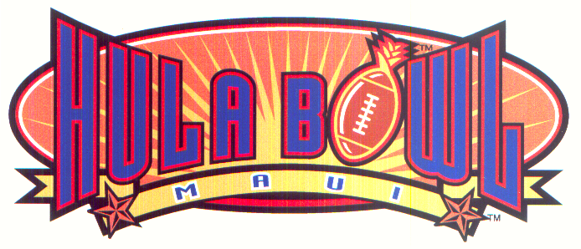
HULA BOWL MAUI
MAUI MALL #B-9
70 E. Kaahumanu Avenue
Kahului, Maui, HI 96732-2113
(808) 871-4141 phone (808) 871-4143
Email: mail@hulabowlmaui.com

TOP 10 KEY QUESTIONS & ANSWERS ABOUT THE ALL-STAR WEEKEND

- WHAT DOES THIS ARRANGEMENT WITH THE NFL REALLY MEAN?

“When we first were asked to take over the running of the event in October of 1994 for the January 1995 game, we knew there were key components which had to be implemented as we began the journey to make this American football tradition the best it could be. Over the last 7 years, we have brought in exclusively the American Football Coaches Association to have the Coaches of the Year coach in the game, the Downtown Athletic Club for hosting the Heisman Trophy and new television and radio contracts which would present the game week and game itself internationally. The NFL has always been involved in the bowl classic, but clearly the future stars of the league wished to interact more with the current stars, coaches and executives during bowl week. This new agreement begins that process and, moreover, clearly indicates how far the game has come as we enter our eighth year.”

- WHAT DOES THE ALL-STAR OR SUPERSTAR TYPE COMPETITION MEAN?

“We anticipate the Pro Stars and Collegiate Stars will mix-it-up for a televised event during the all-star week. ESPN has indicated a tremendous desire to televise this event and it is clear the fans would love it. Just think, if it was last year, Drew Brees throwing to Jerry Rice.”

- WHAT DOES THIS MEAN FOR THE FANS?

“Again, it has been our goal to bring the fans in the stands, on TV and radio, a chance to be up-close and personal with the best of the best. Think about it, now the fans can see those shining collegiate and pro-stars on one weekend in one location!”

- WHERE YOU THINKING ABOUT THE MEDIA ALSO WHEN THIS WAS BEING PUT TOGETHER?

“Yes, in fact, the NFL and ourselves truly believe the media will gain tremendous insight into the current stars and future stars of the NFL by being with the best of the best during this all-star week. Two games, a number of events, all in one location. It is a media persons dream come true!”

- YOU MENTION STREET & SMITH…HOW DO THEY FIT IN?

“We talked about a journey that began in 1994, Today…only 7 ½ years later…Street and Smith, the prominent collegiate and Pro publication, has made the Hula Bowl Maui All-Star Football Classic it’s official all-star game. Look at the covers when they hit the street at the end of the month! We are proud to welcome them to our ohana (family).”

- THE TITLE SPONSOR FOR THE GAME IS STILL AVAILABLE. WERE YOU WAITING FOR THIS UNDERSTANDING TO CONCLUDE?

“Yes, absolutely. We have been working on this unique all-star weekend for sometime, and it made little sense to conclude any negotiations with a new title sponsor until this was announced today. Now, we can inform those parties we are close with, about the date change…the all-star weekend…while ensuring we have a corporate partner that fits in the NFL mold…and, announce an arrangement by the beginning of the football season…some 11 weeks away.”

TOP 10 KEY QUESTIONS & ANSWERS ABOUT THE ALL-STAR WEEKEND

- THE NEW AGREEMENTS WITH THE AFCA, ESPN AND WESTWOOD ONE/CBS RADIO…ARE THEY EXCITED ABOUT THIS ALL-STAR WEEKEND AND DID YOU NEGOTIATE WITH THEM WITH THIS WEEKEND IN MIND?

“Certainly, we planned and structured contracts with this new NFL deal on-the-board. Those entities are extremely excited and will dedicate their resources to promotion of the all-star week with intense fervor.”

- CHRIS FOWLER SAID ON THE TELECAST LAST YEAR THAT THERE IS NO BETTER LOCATION FOR PRACTICES…TO SHOW OFF FOR THE NFL…AND ULTIMATELY FOR AN ALL-STAR GAME. HOW MUCH DID LOCATION PLAY A FACTOR INTO THIS DEAL?

“We are so fortunate to live and work in this great State. Concurrently, we are so proud of what we have accomplished in Maui over the last 4 ½ years. The newly renovated stadium will have additional upgrades this year, but the key is the new grass practice facility and grass turf in the stadium. The players love it and we know the NFL stars will enjoy being with their future teammates. Maui has been special for the Hula Bowl and will continue to be so for years to come. We know the Mayor and MVB will welcome the NFL with open arms.”

- HOW WILL FANS FROM THE MAINLAND COME TO BOTH GAMES?

We have arranged with Classic Destination-Hawaii a national travel package for the all-star weekend and this will be promoted in Street & Smith and nationally through their offices. The 1-800 number is 1-800-367-2333 ext. 223. We anticipate the Heisman Golf Tournament to sell-out earlier this year along with other all-star week events.”

- ANYTHING ELSE NEW?

“We have never rested on our laurels. Last year’s game week and game itself was lauded as ‘the best ever’, but here we are today. Every day of every year we strive to enhance the event. We are proud to partner with the NFL on this truly unique all-star weekend…and, we can only imagine ideas that will come up during the next 236 days, which will culminate in new functions and promotions the end of January to February 3, 2002.”

